PERSONAL EXPENSE TRACKER APPLICATION

IBM-Project-28136-1660107211

NALAIYA THIRAN PROJECT BASED LEARNING ON PROFESSIONAL

READLINESS FOR INNOVATION, EMPLOYNMENT AND ENTERPRENEURSHIP

A PROJECT REPORT

BY

Denisha E (711519BEC020)
Hiruthik Vishnu (711519BEC041)
Jayastathya (711519BEC044) Akash Chandru (711519BEC005)

BACHELOR OF ENGINEERING IN
ELECTRONICS AND COMMUNICATION ENGINEERING
IN
KALAIGNARKARUNANIDHI INSTITUTE OF TECHNOLOGY

COIMBATORE

INDEX
- INTRODUCTION
  - Project Overview
  - Purpose
- LITERATURE SURVEY
  - Existing problem
  - References
  - Problem Statement Definition
- IDEATION & PROPOSED SOLUTION
  - Empathy Map Canvas
  - Ideation & Brainstorming
  - Proposed Solution
  - Problem Solution fit
- REQUIREMENT ANALYSIS

  - Functional requirement
  - Non-Functional requirements
- PROJECT DESIGN

  - Data Flow Diagrams
  - Solution & Technical Architecture
  - User Stories
- PROJECT PLANNING & SCHEDULING

  - Sprint Planning & Estimation
  - Sprint Delivery Schedule
  - Reports from JIRA
- CODING & SOLUTIONING (Explain the features added in the project along with code)

  - Feature 1
  - Feature 2
  - Database Schema (if Applicable)

- TESTING

  - Test Cases
  - User Acceptance Testing
- RESULTS

  - Performance Metrics

- ADVANTAGES & DISADVANTAGES

- CONCLUSION

- FUTURE SCOPE

- APPENDIX

Source Code GitHub Link

PROJECT REPORT-PERSONAL EXPENSE TRACKER (TEAM ID:PNT2022TMID07316)

- INTRODUCTION:

Personal Income Expense Tracker is to easily manage your finance by recording your monthly incomes and expenses. Sometimes at the end of every month, we usually find a shortage of money due to our unaccounted expenses or our bad spending habits. It is necessary to keep track of our incomes and expenses.

Project Overview

Category: Cloud App Development

Skills Required:
IBM cloud , HTML, javascript, IBM object storage, python, kubernates docker IBM db2, IBM container registry

Project Description:
Personal Expense Tracker (PET) is a daily expense management system which is specially designed for non- salaried and salaried personnel for keeping track of their daily expenditure with easy and effective way . Personal expense or finance entails all the financial decisions and activities that a Finance app makes your life easier by helping you to manage your finances efficiently.
A personal finance app will not only help you with budgeting and accounting but also give you helpful insights about money management. Personal expense or finance applications will ask users to add their expenses and based on their expenses wallet balance will be updated which will be visible to the user.
Also, users can get an analysis of their expenditure in graphical forms. They have an option to set a limit for the amount to be used for that particular month if the limit is exceeded the user will be notified with an email alert.

Purpose

The purpose of the project is to help you control your expenses in order to manage the proper spending of money. About the System The Expense Tracker App was created in a HTML web browser that use JavaScript to give user a great interactive experience when using an app.
When you track your spending, you know where your money goes and you can ensure that your money is used wisely. Tracking your expenditures also allows you to understand why you're in debt and how you got there. This will then help you design a befitting strategy of getting out of debt. Budgeting ensures you're not spending more than you're making, allowing you to plan for short- and long-term expenses. It's an easy, helpful way for people with all types of income and expenses to keep their finances in order.

2.LITERATURE SURVEY
Literature review was carried out to gain knowledge and improve the skills needed to complete this project. This chapter shows the different techniques that have been implemented.

2.1 Existing Problem
An expense tracker is a software or application that helps to keep an accurate record of your money inflow and outflow. Many people in India live on a fixed income, and they find that towards the end of the month they don't have sufficient money to meet their needs.

2.2 References

S.No | Paper | Author | Year | Method and Algorithm | Accuracy
1 | Expense Manager Application | A  Velmurugan, et al | 2020 | This paper’s main aim to eliminate the use of sticky notes, spreadsheets and handling of large chunks of data is successful, the new experience is hassle-free and very handy. It uses the Core Data Model. | 94.02%
2 | Cloud based Expense Tracker | Asthha Wahal, et al | 2018 | The waterfall model is used. This application will help its users to overcome the wastage of money. It will guide them and aware them about their daily expenses | 93.4%
3 | Expense | Hrithik | 2020 | This application will help its | 89.92%
 | Tracker : A | Gupta, et al |  | users to manage the cost of
 | Smart |  |  | their daily expenditure. It
 | Approach to |  |  | will guide them and aware
 | Track |  |  | them
 | Everyday |  |  | about their daily expenses.
 | Expense |  |  | Waterfall model is used for
 |  |  |  | the project
 |  |  |  | because all the
 |  |  |  | requirements are clear as
 |  |  |  | this
 |  |  |  | project is not dealing with
 |  |  |  | the clients and
 |  |  |  | hence beforehand planning
 |  |  |  | can be made about
 |  |  |  | how to carry out each
 |  |  |  | phase of development.
4 | Budget Tracker | Malikberdi | 2018 | The scrum agile | 86.79%
 | Highly | Hezretov |  | software development
 | Customizable |  |  | methodology was decided
 | Budgeting |  |  | to follow for this project over
 | Mobile |  |  | the likes of
 | Application |  |  | waterfall model and
 |  |  |  | incremental model. The
 |  |  |  | understudies from the
 |  |  |  | universities spend a great
 |  |  |  | deal dependent on the
 |  |  |  | information and on which need they are following
5 | Spending | Uday Pratap | 2021 | The waterfall model is used. | 91.00%
 | Tracker: A | Singh, et al |  | This application will help its
 | Smart |  |  | users to manage the cost of
 | Approach to |  |  | their daily expenditure. It
 | Track Daily |  |  | will guide them and aware
 | Expense |  |  | them of their daily expenses

2.3 Problem Statement Definition
It is tough to keep track of all the financial decisions and activities that a person makes. Traditional expense tracking methods are inconvenient and unreliable. In order to get a quick overview about your total incomes and expenses and control spending , its convenient to digitize the process by having a personal expense tracker.

Who does the problem affect? | Investors, savers, big spenders, debtors,  consumers on a tight budget, and shoppers.
What are the boundaries of the problem? | Expense tracking software for employees,  students, and regular people.
What is the issue | Being watchful of expenses incurred increases financial strain. Making rash financial decisions could decrease financial security and cause you  to go over your budget.
When does this issue occur? | When employing improper budgeting methods. When you don't keep track of your expenses, you can't determine how much was actually  spent.
Where is the issue occurring | Working people who struggle to keep track of  their expenses.
Why is it important that we fix the problem? | By designating the income for spending, saving, and giving, resolving this problem promotes accountability and encourages financial planning  with purpose. This promotes monetary stability.

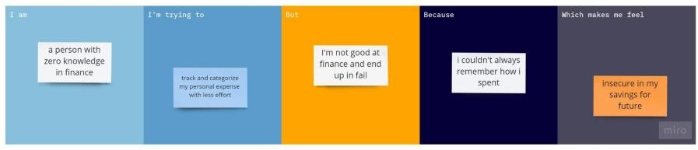

Kevin, who is interested in stock investing, finds it challenging to estimate the cost of stock investing. He can easily and effectively plan out his expenses for investing with the aid of expense tracking.
Raj, a novice budgeter, finds it difficult to keep track of and manage his expenses in the midst of his hectic schedule. Setting priorities for his expenses will enable him to reduce irrational spending.
High school student, Ariyan typically receives a meagre allowance from his parents. So he can spend on both his regular expenses and himself by keeping track of his spending and using good budgeting techniques.

3 .IDEATION & PROPOSED SOLUTION

3.1 Empathy Map Canvas

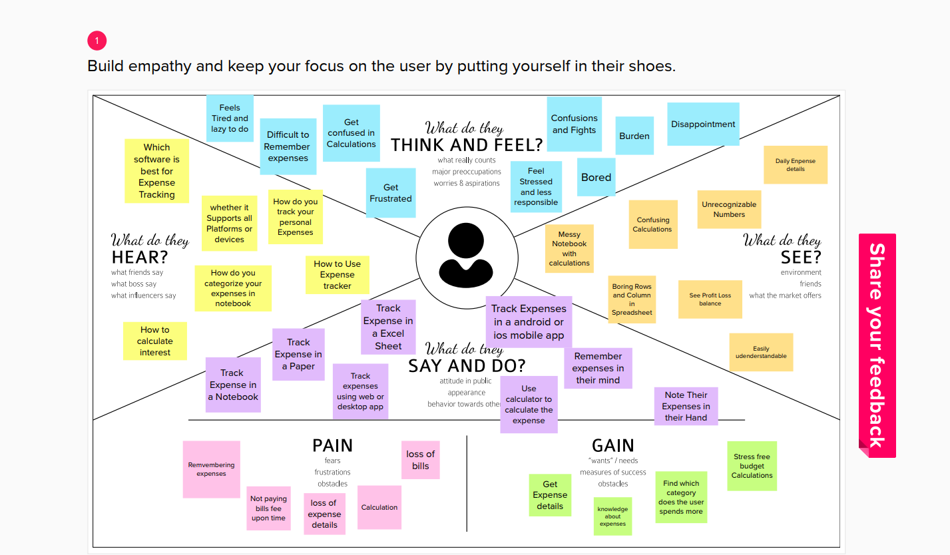

3.2 Ideation & Brainstorming
3.1.a Brainstorm
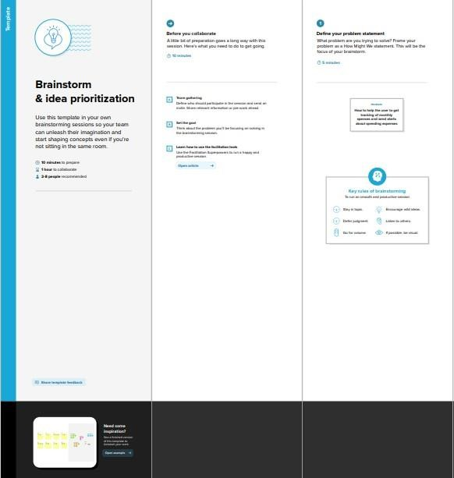

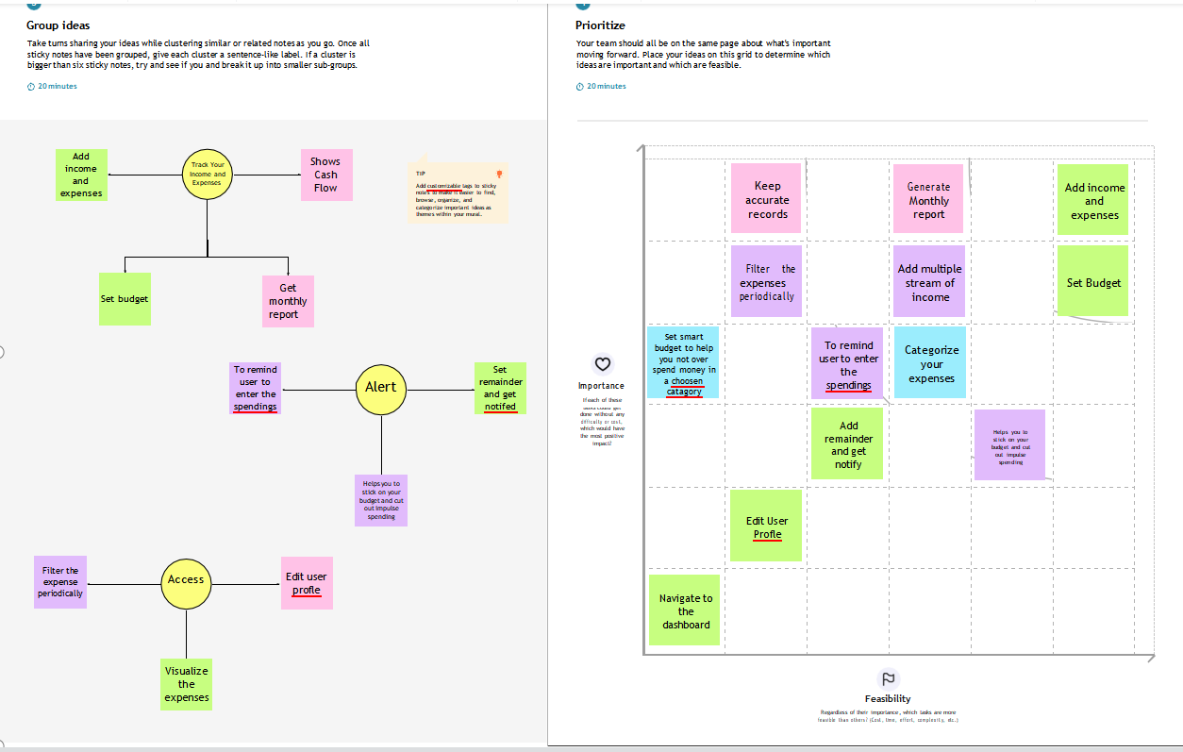

PROBLEM STATEMENT
Many organizations have their own system to record their income and expenses, which they feel is the main key point of their business progress. It is good habit for a personto record daily expenses and earning but due to unawareness and lack of proper applicationsto suit their privacy, lacking decision making capacity people are using traditional note keeping methods to do so. Due to lack of a complete tracking system, there is a 2 constant overload to rely on the daily entry of the expenditure and total estimation till the end of the month.

Who does the problem affect? | Investors, savers, big spenders, debtors,  consumers on a tight budget, and shoppers.
What are the boundaries of the problem? | Expense tracking software for employees,  students, and regular people.
What is the issue | Being watchful of expenses incurred increases financial strain. Making rash financial decisions could decrease financial security and cause you  to go over your budget.
When does this issue occur? | When employing improper budgeting methods. When you don't keep track of your expenses, you can't determine how much was actually  spent.
Where is the issue occurring | Working people who struggle to keep track of  their expenses.
Why is it important that we fix the problem? | By designating the income for spending, saving, and giving, resolving this problem promotes accountability and encourages financial planning  with purpose. This promotes monetary stability.

3.3 Proposed Solution

S.NO. | Parameter | Description
1. | Problem Statement | In paper-based expense tracker system it is difficult to track our monthly expenses manually. In paper-based expense tracker system it is difficult to track our monthly expenses manually.  The paper-based expense records may get lost in case of fire accidents, flood etc.
2. | Scalability of the Solution | This application can handle large number of users and data with high performance and security. This application can adapt for both large-scale and  small-scale purposes. Easily available in all kinds of devices.
3. | Idea / Solution description | Daily expense management system which is specially designed for non-salaried and salaried personnel for keeping track of their daily expenditure with easy and effective way through computerized system which tends to eliminate manual paper works. Personal finance applications will ask users to add their expenses and based on their expenses wallet balance will be updated which will be visible to the user. They have an option to set a limit for the amount to be used for that particular month if the limit is exceeded the user will be notified with an email alert.
4. | Novelty / Uniqueness | The user gets notified when their expense exceeds the limit and also it reminds the user when they

 |  | forgot to make entry. Tracking expenses through SMS. Data analytics on expenses. Future expense prediction
5. | Social Impact / Customer Satisfaction | The application should be able to generate reports of their spending and notify users if they have exceeded their budget. It is designed to be dynamic to produce the prediction. It also provides users’ personal information, their income as well as their expenses. This application can create awareness among common people about finance and stuffs. This application also helps user to be financially  responsible. It Reduces time rather than entering details manually.
6. | Business Model (Revenue Model) | This Application is provided for free of cost. But It will have some advertisement. In premium version there is no advertisement and contains some additional features.

3.4 Problem Solution fit

1. CUSTOMER SEGMENT(S) CS  People are struggling to track their expenses for their savings in the future. | 6. CUSTOMER CONSTRAINTS CC  People have to enter every record manually. The category divided may be blunder or messy. Person who is handling the system must have some technical knowledge | 5. AVAILABLE SOLUTIONS AS  People can add their income and savings to the system for every month. If the savings is not reached our expected limit, an alert message will be sent to the people.
2. JOBS-TO-BE-DONE / J&P  PROBLEMS  Expense Tracker is difficult to track the monthly expense manually. It may get loss during accident, flood etc. | 9. PROBLEM ROOT CAUSE RC | 7. BEHAVIOUR BE
 | As the number could not be | There may keep a
 | identified correctly and | temporary note on their
 | unable to understand the | mobile. He/She will tell the
 | handwritten number, it leads | other persons to remember
 | to loss of the expense | the expense they do while
 | records. | calculating the expenses they
 |  | consider only the expenses
 |  | that are single time and huge
 |  | and leave the rest
3. TRIGGERS TR | 10. YOUR SOLUTION SL | - CHANNELS of BEHAVIOUR CH  - ONLINE  Enter the expense in the system and it leads to properly maintained of the data.  - OFFLINE  Noting the expense manually in notes leads to loss of data and miscalculation of data may occur
It helps people how to save expenses periodically by entering the records in the system. It reduces manual work. | This application helps people related to finances with high security. It helps to provide a visual representation of expenses and notify users of un-tracked expenses with good support.
4. EMOTIONS: BEFORE / AFTER EM
Stress time in managing expenses manually. An easy and efficient way to manage expenses and ensure security

4.FUNCTIONAL REQUIREMENT

4.1 Functional Requirements

FR No. | Functional Requirement (Epic) | Sub Requirement (Story / Sub-Task)
FR-1 | User Registration | Registration through Application  Registration through Gmail
FR-2 | User Confirmation | Confirmation via Email  Confirmation via OTP
FR-3 | User monthly expense  tentative data | Data to be registered in the app
FR-4 | User monthly income data | Data to be registered in the app
FR-5 | Alert / Notification | Alert through E-mail  Alert through SMS
FR-6 | User Budget Plan | Planning and Tracking of user expenses vs budget limit

4.2 Non Functional Requirements

FR No. | Non-Functional Requirement | Description
NFR-1 | Usability | Effectiveness, efficiency, and overall satisfaction  of the user while interacting with the application
NFR-2 | Security | Authentication, authorization, and encryption of  the application
NFR-3 | Reliability | Probability of failure-free operations in a specified  environment for a specified time
NFR-4 | Performance | How the application is functioning and how  responsive the application is to the end-users
NFR-5 | Availability | Without near 100% availability, application reliability and the user satisfaction will affect the  solution
NFR-6 | Scalability | The capacity of the application to handle growth,  especially in handling more users.

5.PRODUCT DESIGN

  - Data Flow Diagrams

A Data Flow Diagram (DFD) is a traditional visual representation of the information flows within a system. A neat and clear DFD can depict the right amount of the system requirement graphically. It shows how data enters and leaves the system, what changes the information, and where data is stored.

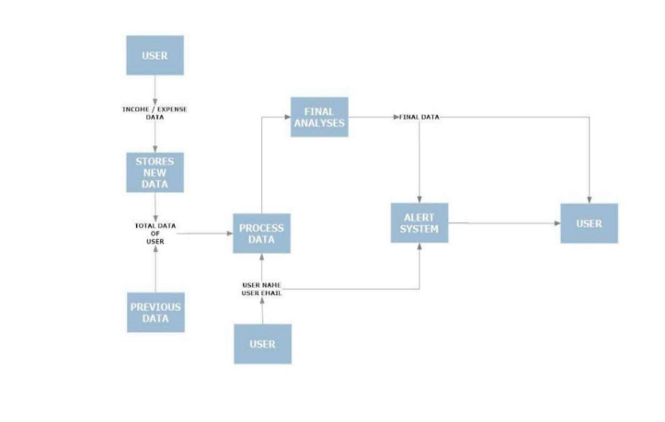

Technical Architecture
The Deliverable shall include the architectural diagram as below and the information as per the table1 & table 2
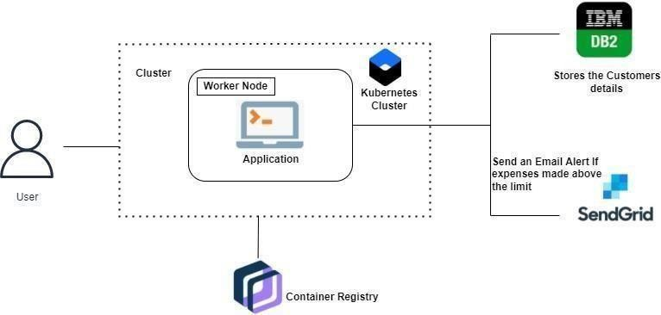

Solution Architecture
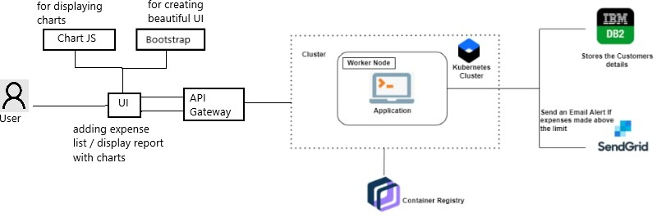

User Stories
Use the below template to list all the user stories of the product.

User Type | Functional Requireme nt (Epic) | User Story Numbe  r | User Story / Task | Acceptance criteria | Priority | Release
Customer | Registratio | USN-1 | As a user, I can | I can access | High
(Mobileuser | n | USN-1 | register for the | my account / | High
& web user |  | USN-1 | application by | dashboard | High
) |  | USN-1 | entering my |  | High
 |  | USN-1 | email, password, |  | High
 |  | USN-1 | and confirming |  | High
 |  | USN-1 | my password. |  | High
 |  | USN-2 | As a user, I will | I can receive | High
 |  | USN-2 | receive | confirmation | High
 |  | USN-2 | confirmation | email & click | High
 |  | USN-2 | email once I have | confirm | High
 |  | USN-2 | registered for the |  | High
 |  | USN-2 | application |  | High
 |  | USN- 3 | As a user, I can | I can register | Low
 |  | USN- 3 | register for the | & access the | Low
 |  | USN- 3 | application | dashboard | Low
 |  | USN- 3 | through Facebook | with Facebook Login | Low
 | Login | USN -4 | As a user, I can | I can access the | High
 | Login | USN -4 | log into the | application | High
 | Login | USN -4 | application by |  | High
 | Login | USN -4 | entering email & |  | High
 | Login | USN -4 | password |  | High
 | Dashboard | USN -5 | As a user I can | I can view my | High
 | Dashboard | USN -5 | enter my income | daily expenses | High
 | Dashboard | USN -5 | and expenditure |  | High
 | Dashboard | USN -5 | details. |  | High
Customer |  | USN 6 | As a customer | I can provide | Mediu
Care |  | USN 6 | care executive | support or | m
Executive |  | USN 6 | I can solve the | solution at any
 |  | USN 6 | log in issues | time 24*7
 |  | USN 6 | and other
 |  | USN 6 | issues of the
 |  | USN 6 | application.
Administrat | Application | USN -7 | As a | I can fix the | Mediu
or | Application | USN -7 | administrator I | bug which | m
 | Application | USN -7 | can upgrade or | arises for the
 | Application | USN -7 | update the | customers
 | Application | USN -7 | application. | and users of
 | Application | USN -7 |  | the
 | Application | USN -7 |  | application

- PROJECT PLANNING & SCHEDULING

6.1 Sprint Planning & Estimation

Use the below template to create product backlog and sprint schedule.

Sprint | Functional  Requirement (Epic) | User Story Number | User Story / Task | Story Points | Priority | Team Members
Sprint-1 | Registration | USN-1 | As a user, I can registerfor the application by entering my email, password, age and  confirm the password. | 8 | High | Denisha,  Hiruthik  Vishnu
Sprint-1 | Login | USN-2 | As a user, I can log into the  application by entering my email and password | 8 | High | Denisha,  Hiruthik  Vishnu
Sprint-2 | Set limit and update | USN-3 | As a user, I can be able to set the amount limit and able to update | 5 | Medium | Hiruthik  Vishnu,  Jayasathya
Sprint-3 | Adding expenses | USN-4 | As a user, I can add the expenses of spending money with many information | 5 | Medium | Jayasathya,  Akash  Chandru
Sprint-4 | Producing output.Change the limit. | USN-5 | As a user, I can see an old expense and if I need to set a monthly limit, we can set it on the application. | 5 | Medium | Denisha,  Akash  Chandru

6.2 Sprint Delivery Schedule

Sprint | Total Story Points | Duration | Sprint Start Date | Sprint End Date(Planned) | Story Points Completed (as on Planned End  Date) | Sprint Release Date(Actual)
Sprint-1 | 20 | 6 Days | 24 Oct 2022 | 29 Oct 2022 | 20 | 29 Oct 2022
Sprint-2 | 20 | 6 Days | 31 Oct 2022 | 05 Nov 2022 | 20 | 05 Nov 2022
Sprint-3 | 20 | 6 Days | 07 Nov 2022 | 12 Nov 2022 | 20 | 12 Nov 2022
Sprint-4 | 20 | 6 Days | 14 Nov 2022 | 19 Nov 2022 | 20 | 19 Nov 2022

6.3 Reports from JIRA
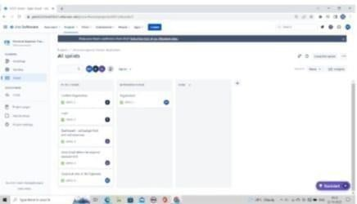

- CODING & SOLUTION

  - Feature 1
    - Expense and revenue tracking.
    - Managing transaction receipts and records.
    - Paying taxes in time.
    - Processing payment and invoices.
    - Create in-depth reports.66

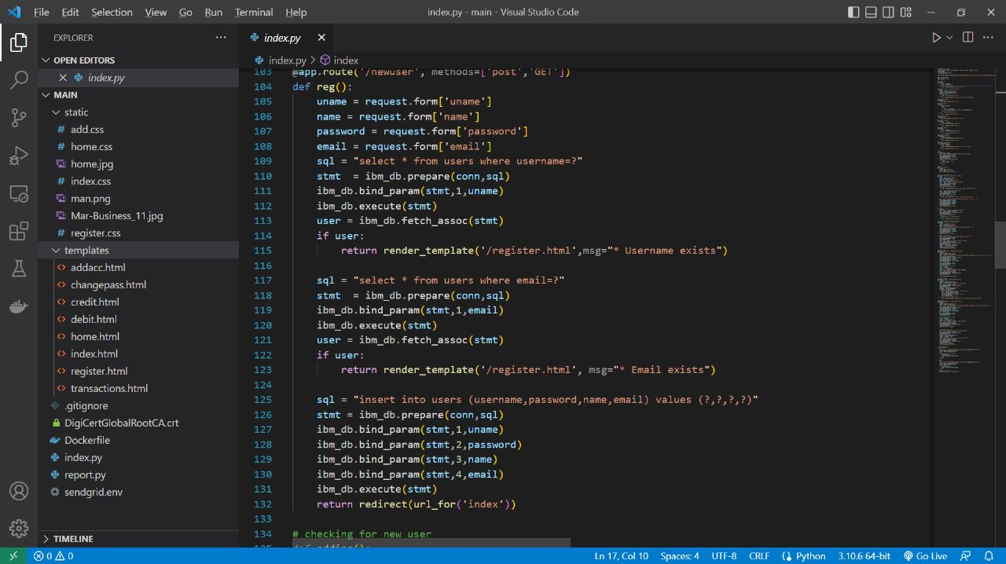

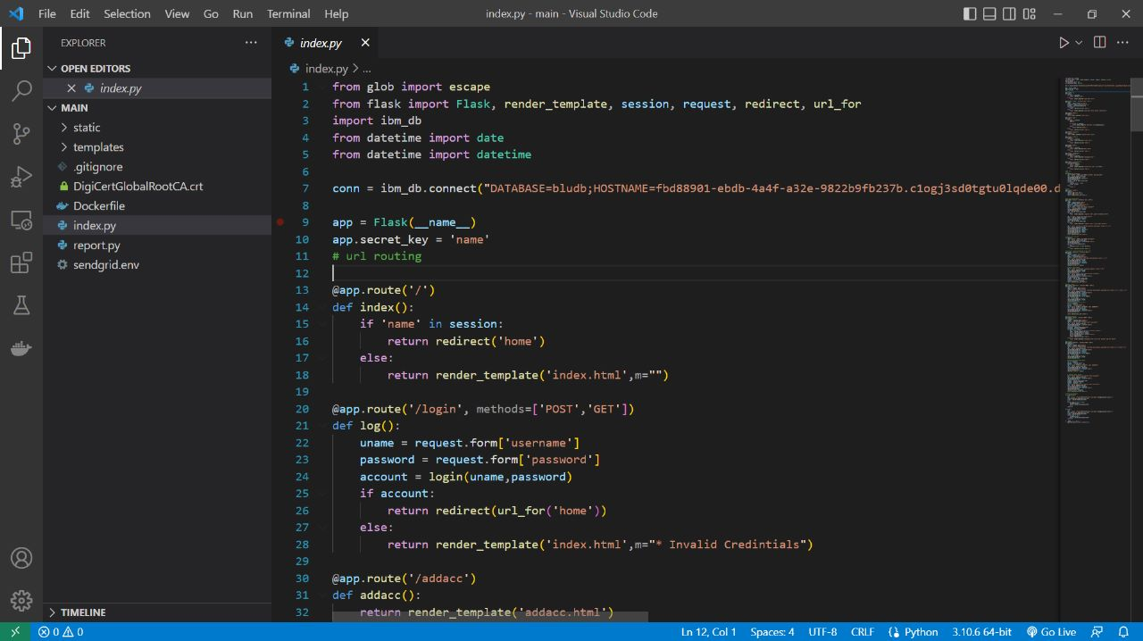

  - Feature 2

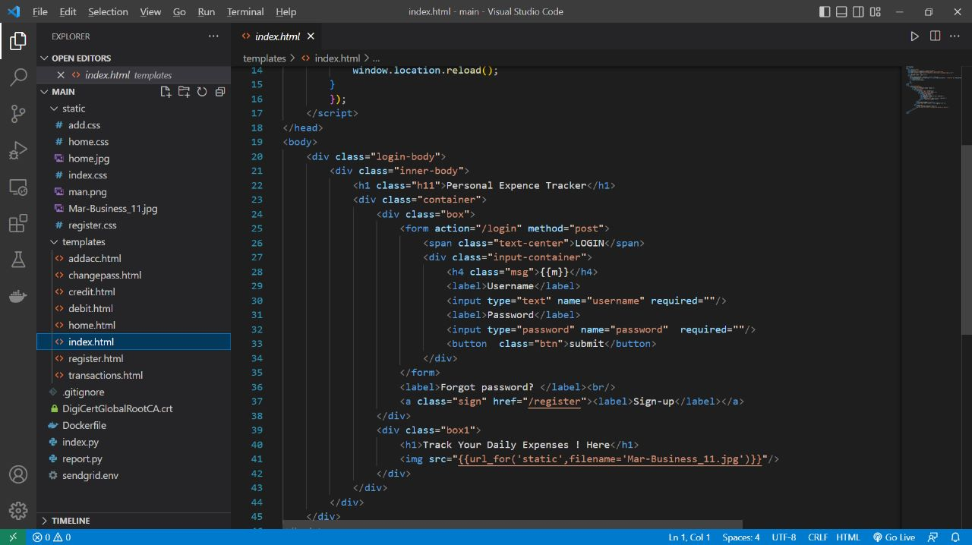

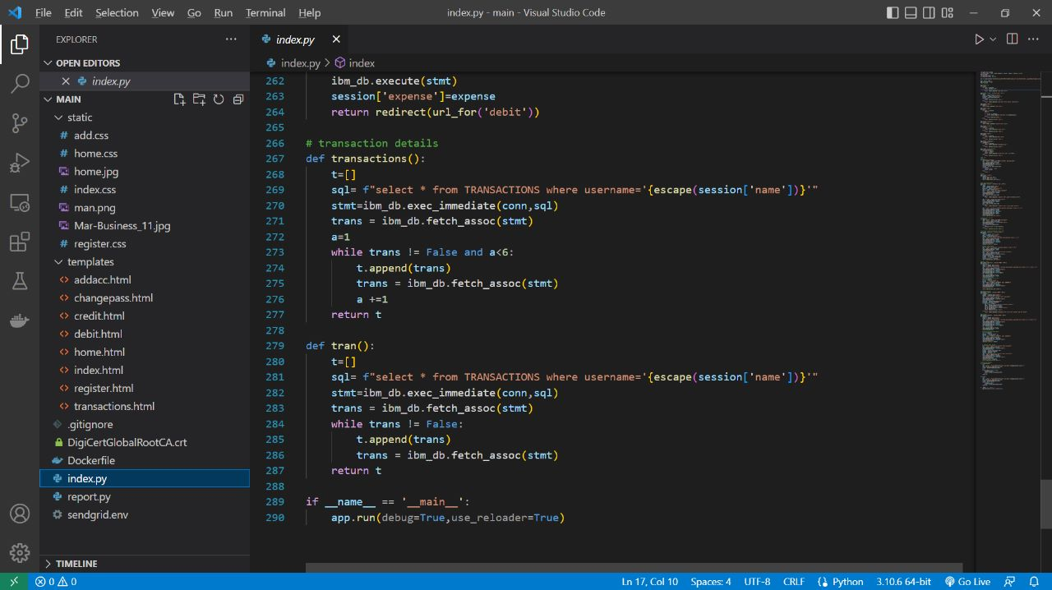

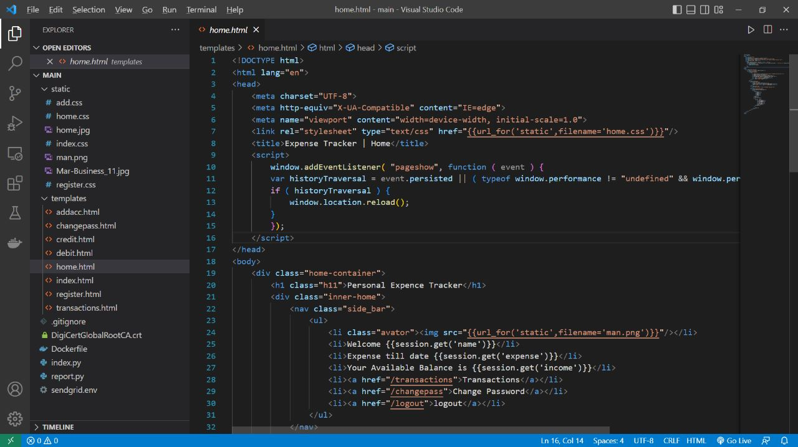

7.3 Database Schema

Tables:
1)Admin
id INT NOT NULL GENERATED ALWAYS AS IDENTITY,username VARCHAR(32) NOT NULL, email VARCHAR(32) NOT NULL,password VARCHAR(32) NOT NULL

2)Expense

id INT NOT NULL GENERATED ALWAYS AS IDENTITY, userid INT NOT NULL, date TIMESTAMP(12) NOT NULL,expensename VARCHAR(32) NOT NULL, amount VARCHAR(32) NOT NULL paymode VARCHAR(32) NOT NULL,
category VARCHAR(32) NOT NULL

3)Limit
id INT NOT NULL GENERATED
ALWAYS AS IDENTITY,userid
VARCHAR(32) NOT NULL, limit
VARCHAR(32) NOT NULL

8.TESTING

8.1 Test Cases

 | Test Case ID |  | Purpose |  | TestCases |  | Result
 | TC1 |  | Authentication |  | Password with  length less than 4  characters |  | Password  cannot be less than 4  characters
 | TC2 |  | Authentication |  | User name  with length less than 2  characters |  | User name  cannot be less than 2  characters
 | TC3 |  | Authentication |  | Valid user  name with minimum 2  characters |  | User name accepted
 |  |  |  |  |  | cannot be less    
 |  |  |  | Password field |  | Password cannot be  
 |  |  |  |   valid password |  | Password accepted
 |  |  |  | Password and Confirm Password did  not match |  | Please enter  password
 |  |  |  | Confirm Password field |  | Please enter  password

8.2 UserAcceptance Testing

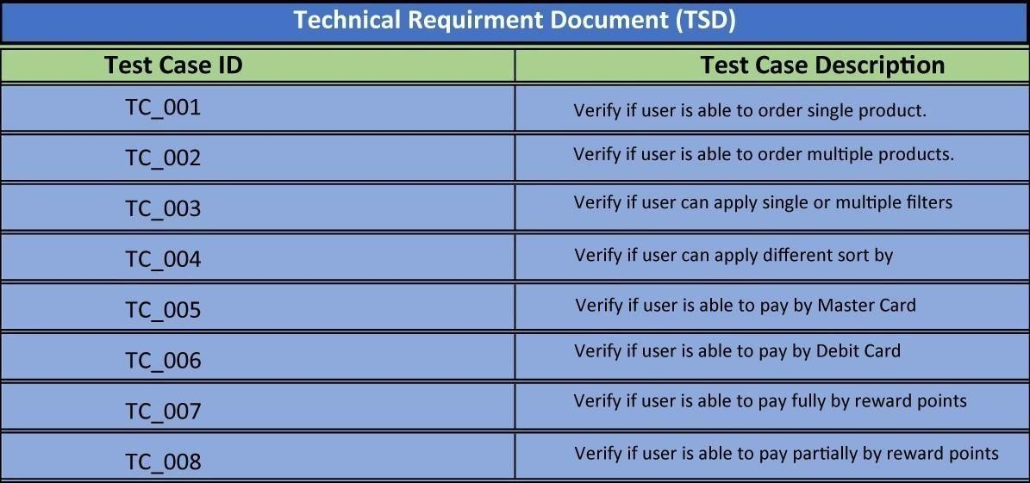

9.RESULTS

9.1 Performance Metrics

  - Tracking income and expenses: Monitoring the income and tracking all expenditures (through bank accounts, mobile wallets, and credit & debit cards).
  - Transaction Receipts: Capture and organize your payment receipts to keep track of your expenditure.
  - Organizing Taxes: Import your documents to the expense tracking app, and it will streamline your income and expenses under the appropriate tax categories.
  - Payments & Invoices: Accept and pay from credit cards, debit cards, net banking, mobile wallets, and bank transfers, and track the status of your invoices and bills in the mobile app itself. Also, the tracking app sends reminders for payments and automatically matches the payments with invoices.
  - Reports: The expense tracking app generates and sends reports to give a detailed insight about profits, losses, budgets, income, balance sheets, etc.
  - E-commerce integration: Integrate your expense tracking app with your eCommerce store and track your sales through payments received via multiple payment methods.
  - Vendors and Contractors: Manage and track all the payments to the vendors and contractors added to the mobile app
  - Access control: Increase your team productivity by providing access control to particular users through custom permissions
  - Track Projects: Determine project profitability by tracking labor costs, payroll, expenses, etc., of your ongoing project
  - Inventory tracking: An expense tracking app can do it all. Right from tracking products or the cost of goods, sending alert notifications when the product is running out of stock or the product is not selling, to purchase orders
  - In-depth insights and analytics: Provides in-built tools to generate reports with easy-to- understand visuals and graphics to gain insights about the performance of your business.
  - Recurrent Expenses: Rely on your budgeting app to track, streamline, and automate all the recurrent expenses and remind you on a timely basis

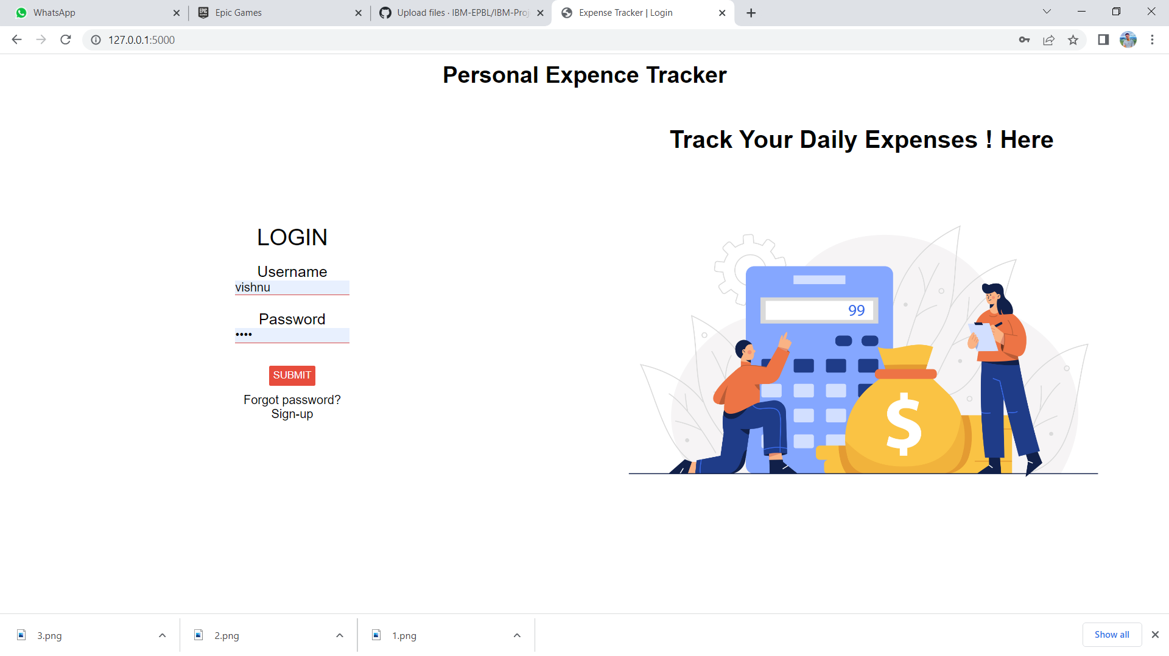

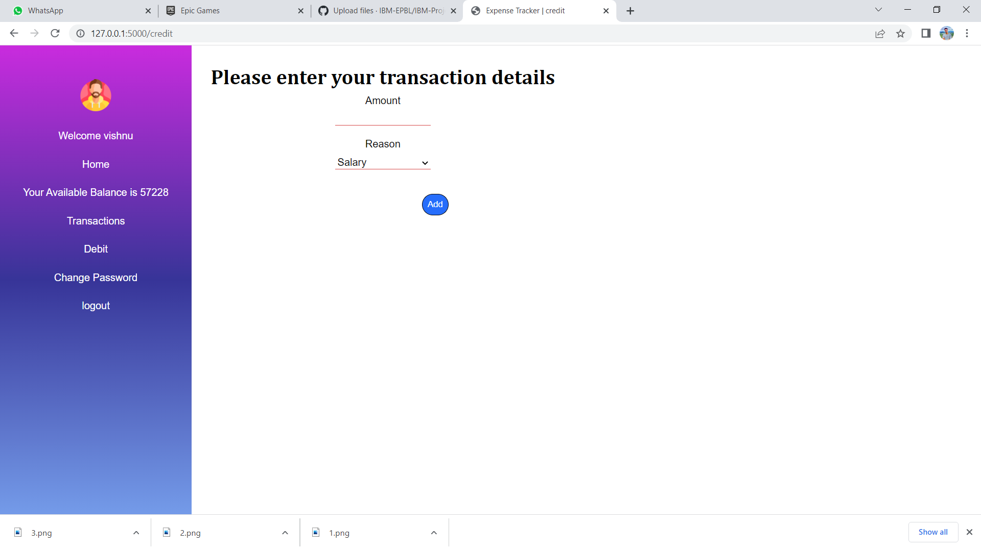

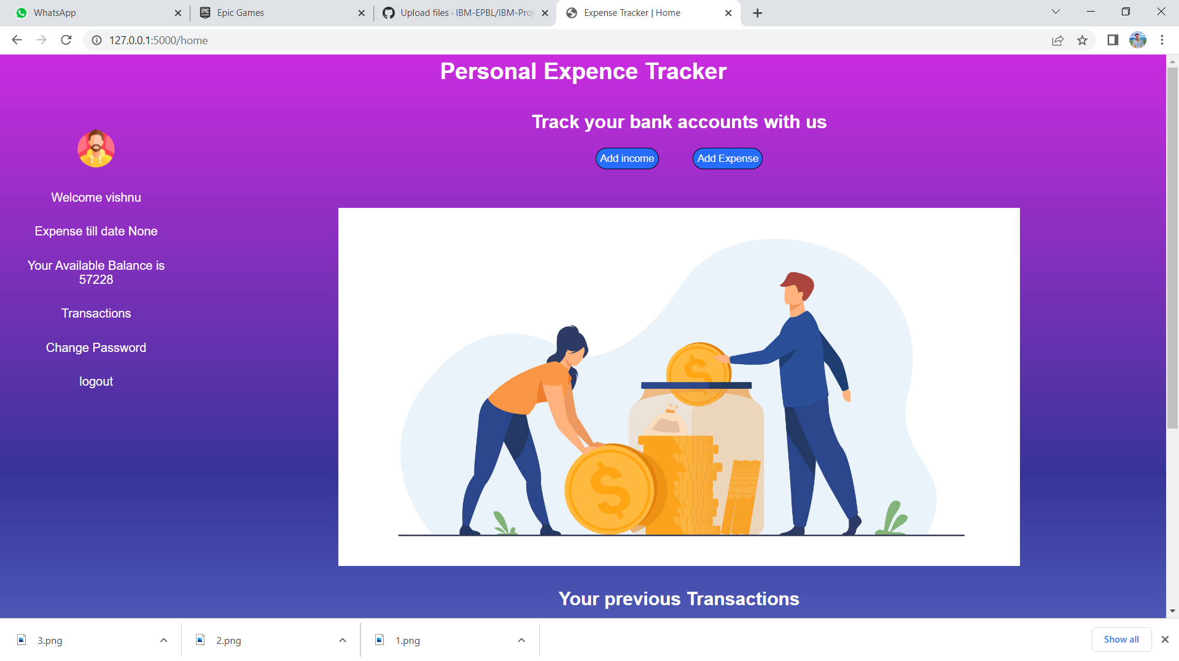

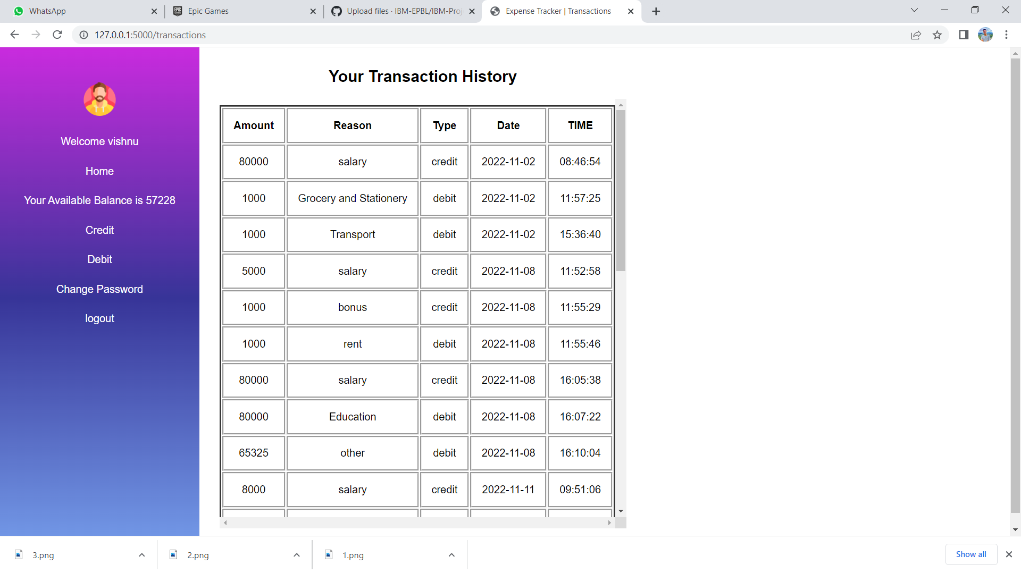
- ADVANTAGES & DISADVANTAGES

10.1 Advantages

- Maintaining Financial Control

When if comes to personal finance, being out of control is not something anybody would strive for. There’s nothing financially worse than feeling like you don’t have any idea what’s going on with your money.

The good news is, when you make an effort to record every financial transaction you make, you are essentially, taking the reins on anything and everything involving your money. At any one time, you will know exactly how much money is sitting in your bank account, and how much you can spend. In other words, when you track your expenses, you take complete control over your finances.
Holding Yourself Accountable

If you have any plans on saving, investing, getting out of debt, or building wealth, what is holding you accountable. I mean, we can all set financial goals, and have financial dreams, but if you aren’t tracking your expenses, there is nothing to hold you accountable when you make a bad financial decision. 1. Susceptible to costly human errors

Did you know that up to 9 out of 10 spreadsheets consist of human errors?

Unfortunately, even the smallest of mistakes in a spreadsheet can cause catastrophic consequences. Fidelity Magellan Fund once suffered a $2.6 billion overstatement when an accountant accidentally omitted the minus sign on a net capital loss of $1.3 billion.

There is always a greater chance of human error with manual processes, especially when it comes to complex data sets, such as those involved with expense management. Failure to accurately track you company’s expenditure and pay invoices on time can wreak havoc on your business’s bottom line.

- Lack of collaboration and access

Because Excel spreadsheets are a single file, only one user at a time may access and modify the data. It can also be challenging to collaborate with other departments because you have to manually share or email a copy of the relevant spreadsheet with your colleagues.

When it comes to expense management data, however, these Excel spreadsheets are frequently shared and proofed across numerous teams and departments. To guarantee that everyone is viewing the current version, users must be rigorous about version control and sharing when updates are made.

- Time-consuming manual processes

The quantity of expense management data you need to review, analyse, and track will grow as your business evolves. The only way to validate your data when using Excel spreadsheets, however, is to manually double check and re-enter any inaccurate information. This is a time-consuming and labour-intensive task.
As a result, Excel spreadsheets slow workers down and reduce accuracy by requiring them to perform repetitive processes that could be simplified or automated using expense management and invoicing software.

- Inaccuracy leads to slower decision making

There’s no denying that manual processes which increase the chances of inaccuracy lead to slower decision making within companies. Extracting expense data and invoices from different departments, as well as consolidating them and summarising the information, is incredibly time consuming.

Because spreadsheets are prone to inaccuracies, everyone involved in processing the information must double-check the data as much as possible, which can further slow the process.

- Lack of version control

The sharing of Excel spreadsheets from team to team might lead to concerns with the data’s version and validity. You should consider who had the most recent access to the data. Who did what to the spreadsheet and when? Can you confirm that the calculations are correct? If you don’t trust the answers, you may need to start all over again.

- Data isn’t updated in real-time

Excel spreadsheets don’t update in real-time, so each update requires manual input. Because Excel spreadsheets can be difficult to modify, they are usually updated at the end of the day or every few days. Typically, this entails keeping daily paper records and then manually entering them to update the Excel spreadsheet at a later date. Not only is this a waste of time, but it also raises the likelihood of data being entered inaccurately or decisions being made based on out-of-date information.

- Increased potential to lose important data

If a spreadsheet owner is unfamiliar with best practices for data storage and backup, they might keep just one version of their spreadsheet in a single location, such as on their desktop.

In the event of a technical issue, however, there’s no guarantee of complete data recovery, meaning a company could lose all of their vital data in a split-second.

  - Improved customer service
  - Cloud-based solution
  - Order Fulfillment
  - Harness Customer Loyalty and Retention

10.2 Disadvantages

- Susceptible to costly human errors

Did you know that up to 9 out of 10 spreadsheets consist of human errors?

Unfortunately, even the smallest of mistakes in a spreadsheet can cause catastrophic consequences. Fidelity Magellan Fund once suffered a $2.6 billion overstatement when an accountant accidentally omitted the minus sign on a net capital loss of $1.3 billion.
There is always a greater chance of human error with manual processes, especially when it comes to complex data sets, such as those involved with expense management. Failure to accurately track you company’s expenditure and pay invoices on time can wreak havoc on your business’s bottom line.

- Lack of collaboration and access

Because Excel spreadsheets are a single file, only one user at a time may access and modify the data. It can also be challenging to collaborate with other departments because you have to manually share or email a copy of the relevant spreadsheet with your colleagues.

When it comes to expense management data, however, these Excel spreadsheets are frequently shared and proofed across numerous teams and departments. To guarantee that everyone is viewing the current version, users must be rigorous about version control and sharing when updates are made.

- Time-consuming manual processes

The quantity of expense management data you need to review, analyse, and track will grow as your business evolves. The only way to validate your data when using Excel spreadsheets, however, is to manually double check and re-enter any inaccurate information. This is a time-consuming and labour-intensive task.

As a result, Excel spreadsheets slow workers down and reduce accuracy by requiring them to perform repetitive processes that could be simplified or automated using expense management and invoicing software.

- Inaccuracy leads to slower decision making

There’s no denying that manual processes which increase the chances of inaccuracy lead to slower decision making within companies. Extracting expense data and invoices from different departments, as well as consolidating them and summarising the information, is incredibly time consuming.

Because spreadsheets are prone to inaccuracies, everyone involved in processing the information must double-check the data as much as possible, which can further slow the process.

- Lack of version control

The sharing of Excel spreadsheets from team to team might lead to concerns with the data’s version and validity. You should consider who had the most recent access to the data. Who did what to the spreadsheet and when? Can you confirm that the calculations are correct? If you don’t trust the answers, you may need to start all over again.

- Data isn’t updated in real-time

Excel spreadsheets don’t update in real-time, so each update requires manual input. Because Excel spreadsheets can be difficult to modify, they are usually updated at the end of the day or every few days. Typically, this entails keeping daily paper records and then manually entering them to update the Excel spreadsheet at a later date. Not only is this a waste of time, but it also raises the likelihood
of data being entered inaccurately or decisions being made based on out-of-date information.

- Increased potential to lose important data

If a spreadsheet owner is unfamiliar with best practices for data storage and backup, they might keep just one version of their spreadsheet in a single location, such as on their desktop.

11.CONCLUSION

Taking proper care of our record is crucial in every business, no matter how big or little, we must understand. We must educate ourselves about the idea of effective inventory management and its applications because we can see that managers do not fully grasp it. A company's inventory management system is one of the reasons for its failure. Many customs to combat failure are present, and we can start from this point. Modern technologies can support us in managing and keeping an eye on our inventory. We may learn, put new ideas into practice, and assess our company.

12.FUTURE SCOPE

  - It will have various options to keep record (for example Food, Travelling Fuel, Salary etc.).
  - Automatically it will keep on sending notifications for our daily expenditure.

  - In today’s busy and expensive life, we are in a great rush to make moneys, but at the end of the month we broke off. As we are unknowingly spending money on title and unwanted things. So, we have come over with the plan to follow our profit.
  - Here user can define their own categories for expense type like food, clothing, rent and bills where they have to enter the money that has been spend and likewise can add some data in extra data to indicate the expense.

13.APPENDIX

SOURCE CODE:

LOGIN PAGE

<!DOCTYPE html>
<html lang="en">
<head>
<meta charset="UTF-8">
<meta http-equiv="X-UA-Compatible" content="IE=edge">
<meta name="viewport" content="width=device-width, initial-scale=1.0">
<link rel="stylesheet" type="text/css" href="{{ url_for('static',filename='index.css')}}">

<title>Expense Tracker | Login</title>
<script>
window.addEventListener( "pageshow", function ( event ) {
var historyTraversal = event.persisted || ( typeof window.performance != "undefined" && window.performance.navigation.type === 2 );
if ( historyTraversal ) {
window.location.reload();
}
});
</script>
</head>
<body>
<div class="login-body">
<div class="inner-body">
<h1 class="h11">Personal Expence Tracker</h1>
<div class="container">
<div class="box">
<form action="/login" method="post">
<span class="text-center">LOGIN</span>
<div class="input-container">
<h4 class="msg">{{m}}</h4>
<label>Username</label>
<input type="text" name="username" required=""/>
<label>Password</label>
<input type="password" name="password" required=""/>
<button class="btn">submit</button>
</div>
</form>
<label>Forgot password? </label><br/>
<a class="sign" href="/register"><label>Sign-up</label></a>
</div>
<div class="box1">
<h1>Track Your Daily Expenses ! Here</h1>
<img src="{{url_for('static',filename='Mar-Business_11.jpg')}}"/>
</div>
</div>
</div>
</div>
</body>
</html>

HOME PAGE

<!DOCTYPE html>
<html lang="en">
<head>
<meta charset="UTF-8">
<meta http-equiv="X-UA-Compatible" content="IE=edge">
<meta name="viewport" content="width=device-width, initial-scale=1.0">
<link rel="stylesheet" type="text/css" href="{{url_for('static',filename='home.css')}}"/>
<title>Expense Tracker | Home</title>
<script>
window.addEventListener( "pageshow", function ( event ) {
var historyTraversal = event.persisted || ( typeof window.performance != "undefined" && window.performance.navigation.type === 2 );
if ( historyTraversal ) {
window.location.reload();
}
});
</script>
</head>
<body>
<div class="home-container">
<h1 class="h11">Personal Expence Tracker</h1>
<div class="inner-home">
<nav class="side_bar">
<ul>
<li class="avator"><img src="{{url_for('static',filename='man.png')}}"/></li>
<li>Welcome {{session.get('name')}}</li>
<li>Expense till date {{session.get('expense')}}</li>
<li>Your Available Balance is {{session.get('income')}}</li>
<li><a href="/transactions">Transactions</a></li>
<li><a href="/changepass">Change Password</a></li>
<li><a href="/logout">logout</a></li>
</ul>
</nav>
<div class="rightside">
<div class="right-top">
<h2>Track your bank accounts with us</h2>
<a href="/credit"><button class="btn">Add income</button></a>
<a href="/debit"><button class="btn">Add Expense</button></a>
</div>
<div class="home_img">
<img src="{{url_for('static',filename='home.jpg')}}"/>
</div>
<div class="transaction_table">
<h2>Your previous Transactions</h2>
<table>
<thead>
<th>Amount</th>
<th>Reason</th>
<th>Type</th>
<th>Date</th>
<th>TIME</th>
</thead>
{% set a=0%}
{% for x in tra %}
<tr>
{% if a < 5 %}
<td>{{x.AMOUNT}}</td>
<td>{{x.REASON}}</td>
<td>{{x.TYPE}}</td>
<td>{{x.DATE}}</td>
<td>{{x.TIME}}</td>
{% set a=a+1 %}
{% endif %}
</tr>

{% endfor %}
</table>
</div>
</div>
</div>
</div>
</body>
</html>

The python code to Connect with DB

from glob import escape
from flask import Flask, render_template, session, request, redirect, url_for
import ibm_db
from datetime import date
from datetime import datetime

conn = ibm_db.connect("DATABASE=bludb;HOSTNAME=fbd88901-ebdb-4a4f-a32e-9822b9fb237b.c1ogj3sd0tgtu0lqde00.databases.appdomain.cloud;PORT=32731;SECURITY=SSL;SSLServerCertificate=DigiCertGlobalRootCA.crt;UID=brd83146;PWD=86sieylZYORbSY3i",'','')

app = Flask(__name__)
app.secret_key = 'name'
# url routing

@app.route('/')
def index():
if 'name' in session:
return redirect('home')
else:
return render_template('index.html',m="")

@app.route('/login', methods=['POST','GET'])
def log():
uname = request.form['username']
password = request.form['password']
account = login(uname,password)
if account:
return redirect(url_for('home'))
else:
return render_template('index.html',m="* Invalid Credintials")

@app.route('/addacc')
def addacc():
return render_template('addacc.html')

@app.route('/home')
def home():
if 'name' in session:
addinc()
sql = "select expense from expenses where username=?"
stmt = ibm_db.prepare(conn,sql)
ibm_db.bind_param(stmt,1,session['name'])
ibm_db.execute(stmt)
expense = ibm_db.fetch_assoc(stmt)
expense = expense['EXPENSE']
session['expense'] = expense
if 'income' in session:
return render_template('home.html',tra=transactions())
else:
return redirect('addacc')
else:
return redirect(url_for('index'))

@app.route('/register')
def register():
return render_template('register.html',msg="")

@app.route('/credit')
def credit():
if 'name' in session:
return render_template('credit.html')
else:
return redirect(url_for('index'))

@app.route('/debit')
def debit():
if 'name' in session:
return render_template('debit.html')
else:
return redirect(url_for('index'))

@app.route('/changepass')
def changepass():
if 'name' in session:
return render_template('changepass.html')
else:
return redirect(url_for('index'))

@app.route('/transactions')
def transactionsfull():
if 'name' in session:
transs = tran()
return render_template('transactions.html',tra =transs )
else:
return redirect(url_for('index'))

# API call
#login
def login(name,password):
sql = "SELECT * FROM users WHERE username=? and password=?"
stmt = ibm_db.prepare(conn,sql)
ibm_db.bind_param(stmt,1,name)
ibm_db.bind_param(stmt,2,password)
ibm_db.execute(stmt)
account = ibm_db.fetch_assoc(stmt)
if account:
session['name'] = name
return account
else:
return 0

#logout
@app.route('/logout')
def logout():
session.pop('name',None)
session.pop('income',None)
return redirect(url_for('index'))

# new user registration
@app.route('/newuser', methods=['post','GET'])
def reg():
uname = request.form['uname']
name = request.form['name']
password = request.form['password']
email = request.form['email']
sql = "select * from users where username=?"
stmt = ibm_db.prepare(conn,sql)
ibm_db.bind_param(stmt,1,uname)
ibm_db.execute(stmt)
user = ibm_db.fetch_assoc(stmt)
if user:
return render_template('/register.html',msg="* Username exists")

sql = "select * from users where email=?"
stmt = ibm_db.prepare(conn,sql)
ibm_db.bind_param(stmt,1,email)
ibm_db.execute(stmt)
user = ibm_db.fetch_assoc(stmt)
if user:
return render_template('/register.html', msg="* Email exists")

sql = "insert into users (username,password,name,email) values (?,?,?,?)"
stmt = ibm_db.prepare(conn,sql)
ibm_db.bind_param(stmt,1,uname)
ibm_db.bind_param(stmt,2,password)
ibm_db.bind_param(stmt,3,name)
ibm_db.bind_param(stmt,4,email)
ibm_db.execute(stmt)
return redirect(url_for('index'))

# checking for new user
def addinc():
sql1= "SELECT * FROM income WHERE username=?"
stmt = ibm_db.prepare(conn,sql1)
ibm_db.bind_param(stmt,1,session.get('name'))
ibm_db.execute(stmt)
inc = ibm_db.fetch_assoc(stmt)
if inc:
session['income'] = inc['BALANCE']
else:
return redirect(url_for('addacc'))

# inserting income and balance for new user
@app.route('/addincome', methods=['POST'] )
def addin():
income = request.form['income']
name = request.form['uname']
balance = request.form['balance']
sql = "insert into income (username,income,balance) values (?,?,?)"
stmt = ibm_db.prepare(conn,sql)
ibm_db.bind_param(stmt,1,name)
ibm_db.bind_param(stmt,2,income)
ibm_db.bind_param(stmt,3,balance)
ibm_db.execute(stmt)
session['income'] = balance

#adding expense data
sql = "insert into expenses (username,expense) values (?,'0')"
stmt = ibm_db.prepare(conn,sql)
ibm_db.bind_param(stmt,1,name)
ibm_db.execute(stmt)
return redirect(url_for('home'))

#addding credit
@app.route('/addcredit', methods=['POST','GET'])
def addcredit():
amount = request.form['amount']
reason = request.form['reason']
sql = "insert into transactions (username,reason,amount,type,date,time) values (?,?,?,'credit',?,?)"
stmt = ibm_db.prepare(conn,sql)
ibm_db.bind_param(stmt,1,session['name'])
ibm_db.bind_param(stmt,3,amount)
ibm_db.bind_param(stmt,2,reason)
ibm_db.bind_param(stmt,4,date.today())
tt = datetime.now()
time = tt.strftime("%H:%M:%S")
ibm_db.bind_param(stmt,5,time)
ibm_db.execute(stmt)
#updating balance after credit
acc = int(amount)
new_var = session['income']
balance = int(new_var) + acc
sql = "update INCOME set BALANCE=? where USERNAME=?"
stmt = ibm_db.prepare(conn,sql)
ibm_db.bind_param(stmt,1,balance)
ibm_db.bind_param(stmt,2,session['name'])
ibm_db.execute(stmt)

return redirect(url_for('credit'))

#changing password
@app.route('/change', methods=['POST','GET'])
def chanpass():
oldpass = request.form['oldpass']
newpass = request.form['newpass']
sql = "select password from users where username=?"
stmt = ibm_db.prepare(conn,sql)
ibm_db.bind_param(stmt,1,session['name'])
ibm_db.execute(stmt)
password = ibm_db.fetch_assoc(stmt)
password = password['PASSWORD']
if (password == oldpass):
sql = "update users set password=? where username=?"
stmt = ibm_db.prepare(conn,sql)
ibm_db.bind_param(stmt,1,newpass)
ibm_db.bind_param(stmt,2,session['name'])
ibm_db.execute(stmt)
return redirect(url_for('home'))
else:
return render_template('changepass.html',msg = "old password does not match")

#adding debit
@app.route('/adddebit', methods=['POST','GET'])
def adddebit():
amount = request.form['amount']
reason = request.form['reason']
sql = "insert into TRANSACTIONS (username,reason,amount,type,date,time) values (?,?,?,'debit',?,?)"
stmt = ibm_db.prepare(conn,sql)
ibm_db.bind_param(stmt,1,session['name'])
ibm_db.bind_param(stmt,3,amount)
ibm_db.bind_param(stmt,2,reason)
ibm_db.bind_param(stmt,4,date.today())
tt = datetime.now()
time = tt.strftime("%H:%M:%S")
ibm_db.bind_param(stmt,5,time)
ibm_db.execute(stmt)

#updating balance after debit
acc = int(amount)
new_var = session['income']
balance = int(new_var) - acc
sql = "update INCOME set BALANCE=? where USERNAME=?"
stmt = ibm_db.prepare(conn,sql)
ibm_db.bind_param(stmt,1,balance)
ibm_db.bind_param(stmt,2,session['name'])
ibm_db.execute(stmt)
session['income'] = balance

# updating debit amount
sql = "select expense from expenses where username=?"
stmt = ibm_db.prepare(conn,sql)
ibm_db.bind_param(stmt,1,session['name'])
ibm_db.execute(stmt)
expense = ibm_db.fetch_assoc(stmt)
expense = expense['EXPENSE']
expense = expense + acc
sql = "update expenses set expense=? where username=?"
stmt = ibm_db.prepare(conn,sql)
ibm_db.bind_param(stmt,1,expense)
ibm_db.bind_param(stmt,2,session['name'])
ibm_db.execute(stmt)
session['expense']=expense
return redirect(url_for('debit'))

# transaction details
def transactions():
t=[]
sql= f"select * from TRANSACTIONS where username='{escape(session['name'])}'"
stmt=ibm_db.exec_immediate(conn,sql)
trans = ibm_db.fetch_assoc(stmt)
a=1
while trans != False and a<6:
t.append(trans)
trans = ibm_db.fetch_assoc(stmt)
a +=1
return t

def tran():
t=[]
sql= f"select * from TRANSACTIONS where username='{escape(session['name'])}'"
stmt=ibm_db.exec_immediate(conn,sql)
trans = ibm_db.fetch_assoc(stmt)
while trans != False:
t.append(trans)
trans = ibm_db.fetch_assoc(stmt)
return t

if __name__ == '__main__':
app.run(debug=True,use_reloader=True)

CONCLUSION

Thus we conclude with our final deliverables of the project Personal expense tracker.

GITHUB LINK:

https://github.com/IBM-EPBL/IBM-Project-28136-1660107211

DEMO LINK:

https://drive.google.com/file/d/1ZRuOYPT4jSAyebJB436o9BluBYHmpG0c/view?usp=share_link

